2025
TEAM: DB MASTERS
Amrutha Manjunath
Pruekson Lukkanothai
Nishant Malik
Ibrahim Aljezani
10-07-2025
BST-BCS-23A – Data Bases Project Final Report

Table of Contents

I. Database Initial Study and Analysis 2
i. Summary of the data gathering methods 2
ii. Summary of the information requirements of the system 3
II. Database Design: Conceptual Design 5
i. Initial Entity Relationship (and/or EER) Model 5
ii. Business Rules 6
iii. Data Dictionary 8
III. Database Design: Logical Design 11
i. Relational Schema 11
IV. Physical Design/Implementation 12
V. Querying/Reporting 13
i. Email addresses of all participants whose paper(s) have been accepted (avg review score >=7) 13
ii. Sponsor summary across tiers (#sponsors, net earnings, average earning per sponsor) 14
iii. Specializations of academic participants 15
iv. Organizations of professional participants 16
v. Number of sessions chaired by each reviewer 17
vi. Count of papers and average review score by each reviewer 18
vii. Ticket Summary based on ticket type (number of tickets sold and net earnings in EUR) 19
viii. Details of papers under the topic “Digital Forensics” 20
ix. Booth Assignments of platinum sponsors 21
x. Session schedule with date, timings and assigned rooms (for offline sessions) 22
xi. Topics Summary (number of papers received and interest by participants) 23

I. Database Initial Study and Analysis

i. Summary of the data gathering methods
We used the following data gathering methods:
- Online Research:
  - We analysed academic & technical conference websites including IACyC 2025 by CyberMACS (https://cybermacs.org/). This provided insights into submission workflows, review processes, participant registration, and session scheduling.
  - We researched the venue of the IACyC 2025 i.e. Metropol Lake Resort (https://metropol-ohrid.com.mk/) to gather realistic inputs for rooms/halls
  - We used ChatGPT primarily as a research tool (such as to find relevant websites for data generation) and as a learning resource.
- Document Analysis: We thoroughly examined the provided documentation for this project:
  - Project overview document helped us define the entities, relationships, key attributes and information requirements
  - Project guidelines document helped us structure the project workflow and report
- Team Brainstorming and Discussion

We also used the following tools & websites:
- Draw.io for collaborating and creating the Entity Relationship Diagram (conceptual design).
- Mockaroo and Tonic Fabricate for creating sample data for most of the tables of the database.
- MySQL as RDBMS for setting up the database & tables (physical implementation), generating relationships schema (logical design) and querying data.
- Google Drive, G-Suite, MS-Office & MS-Teams for general collaboration and report creation.

ii. Summary of the information requirements of the system
The following summarizes the information requirements:
- Objective: To design and implement a relational database for the CyberMACS International Applied Cybersecurity Conference (IACyC 2025). The project emphasizes on the development of effective queries and reports to support data-driven decision-making within the context of conference management.
- Key actors/roles:
  - Participants
  - Reviewers
  - Speakers
  - Sponsors
  - Organizers
- Information needed by each role:
  - Participants:
    - Notifications on paper submission deadlines
    - Notifications of acceptance/rejection to participants whose submitted papers have been reviewed
    - Notifications on program schedule with session topics and speaker names
  - Organizers:
    - Ticket sales summary
    - List of submitted papers with status (under review, accepted, rejected)
    - Invite participants whose papers have been accepted
    - Count of papers assigned to each reviewer
    - Scheduled sessions with speaker and topic information
    - Sponsor details and contact information
    - Net earnings through ticket sales and sponsorship
  - Reviewers:
    - Assigned papers
    - Deadline notifications
    - Session schedule to act as chairperson
  - Speakers:
    - Notification of session schedule and venue
  - Sponsors:
    - Visibility in event materials and session banners
    - Booth assignments
    - Session assignments as speaker
- Key system outputs (queries/reports):
  - Participant affiliation summary
  - Report on ticket sales
  - Report on sponsor contribution
  - Report of accepted papers
  - Reviewer performance summary
  - Event schedule with session times and rooms
  - Speaker assignment summary

II. Database Design: Conceptual Design

i. Initial Entity Relationship (and/or EER) Model
We have created the Entity Relationship Diagram using Chen Notation:
- Regular entities (blue boxes) and sub-classes (lighter blue boxes)
- Bridge entities (green boxes) have been included to convert M:N relationships between regular entities
- Relationships between entities (yellow diamond boxes)

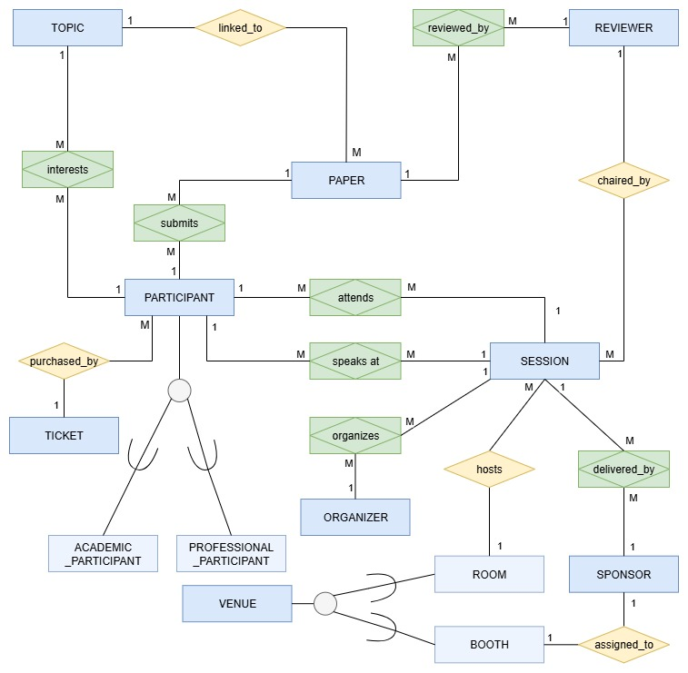

ii. Business Rules
The business rules mentioned below state the relationship between the entities:

PARTICIPANT - TOPIC (interest)
A PARTICIPANT is interested in one to three TOPICs.
A TOPIC can have one or many PARTICIPANTs interested in it.

PARTICIPANT - PAPER (submission)
A PARTICIPANT submits one or many PAPERs.
A PAPER is submitted by one or many PARTICIPANTs.

PARTICIPANT - SESSION (attendance)
A PARTICIPANT attends one or many SESSIONs.
A SESSION is attended by one or many PARTICIPANTs.

PARTICIPANT - SESSION (speaker)
A PARTICIPANT speaks at one or many SESSIONs.
A SESSION is delivered by one or many PARTICIPANTs.

PARTICIPANT – TICKET (purchasing)
A PARTICIPANT purchases one TICKET.
A TICKET is purchased by one or many PARTICIPANTs.

REVIEWER - PAPER (reviewing)
A REVIEWER reviews one or many PAPERs.
A PAPER is reviewed by two or more REVIEWERs.

REVIEWER - SESSION (chairing)
A REVIEWER chairs a one or many SESSIONs.
A SESSION is chaired by one REVIEWER.

PAPER - TOPIC (classification)
A PAPER linked to only one TOPIC.
A TOPIC is linked to one or many PAPERS.

SPONSOR – BOOTH (assignment)
A SPONSOR is assigned one BOOTH (VENUE).
A BOOTH (VENUE) is assigned to one SPONSOR.

SPONSOR – SESSION (speaker)
A SPONSOR speaks at one or many SESSIONS.
A SESSION is delivered by one or many SPONSORS.

ROOM – SESSION (location)
A ROOM (VENUE) hosts one or many SESSIONs.
A SESSION is held at one ROOMs (VENUE).

ORGANIZER – SESSION (organizing)
An ORGANIZER organizes one or many SESSIONs.
A SESSION is organized by one or many ORGANIZERs.

iii. Data Dictionary
The table has been split into three parts.
Data Dictionary - Part 1:
Table Name | Attribute Name | Contents | Type | Format | Domain | Required | PK or FK | FK Referenced Table
PARTICIPANT | Participant_ID | Participant unique ID | INT | 1 | 1-9999 | Y | PK
 | Participant_FName | Participant first name | VARCHAR(50) | Xxxxxxxx |  | Y
 | Participant_LName | Participant last name | VARCHAR(50) | Xxxxxxxx |  | Y
 | Participant_Email | Participant email ID | VARCHAR(100) | xx@yy.zz |  | Y
 | Participant_Phone | Participant phone number | VARCHAR(25) | +XX XXX XXX XXXX
 | Ticket_Type | Ticket type purchased by participant | INT | 1 | 1-4 | Y | FK | TICKET
ACADEMIC_  PARTICIPANT | Participant_ID | Participant unique ID | INT | 1 | 1-9999 | Y | PK, FK | PARTICIPANT
 | Academic_School | Participant school name | VARCHAR(255) | Xxxxxxxx |  | Y
 | Academic_Specialization | Participant major (technical area) | VARCHAR(255) | Xxxxxxxx |  | Y
 | Academic_Type | Participant - Student or Lecturer | ENUM | Student | [Student, Lecturer/  Professor] | Y
PROFESSIONAL_PARTICIPANT | Participant_ID | Participant unique ID | INT | 1 | 1-9999 | Y | PK, FK | PARTICIPANT
 | Professional_Organization | Professional organization | VARCHAR(255) | Xxxxxxxx |  | Y
 | Professional_JobTitle | Professional job title | VARCHAR(100) | Xxxxxxxx |  | Y
 | Professional_Industry | Professional industry | VARCHAR(100) | Xxxxxxxx |  | Y
 | Professional_Sector | Professional sector | ENUM | Public | [Public, Private] | Y
TICKET | Ticket_Type | Ticket type purchased by participant | INT | 1 | 1-4 | Y | PK
 | Ticket_Desc | Ticket description (CyberMAC, Student, Regular, Sponsor) | VARCHAR(100) | Xxxxxxxx |  | Y
 | Ticket_Price | Ticket price | INT | 100 | 0-250 | Y
ORGANIZER | Organizer_ID | Organizer unique ID | INT | 1 | 1-250 | Y | PK
 | Organizer_FName | Organizer first name | VARCHAR(50) | Xxxxxxxx |  | Y
 | Organizer_LName | Organizer last name | VARCHAR(50) | Xxxxxxxx |  | Y
 | Organizer_Email | Organizer email | VARCHAR(100) | xx@yy.zz |  | Y
 | Organizer_Phone | Organizer phone number | VARCHAR(25) | +XX XXX XXX XXXX
 | Organizer_Affiliation | Organizer university affiliation | VARCHAR(255) | Xxxxxxxx |  | Y
 | Organizer_Role | eg. coordinator, planner, manager, staff | VARCHAR(100) | Xxxxxxxx
organizes | Organizer_ID | Organizer unique ID | INT | 1 | 1-250 | Y | FK | ORGANIZER
 | Session_ID | Session unique ID | INT | 1 | 1-120 | Y | FK | SESSION
Data Dictionary - Part 2:
Table Name | Attribute Name | Contents | Type | Format | Domain | Required | PK or FK | FK Referenced Table
REVIEWER | Reviewer_ID | Reviewer unique ID | INT | 1 | 1-50 | Y | PK
 | Reviewer_FName | Reviewer first name | VARCHAR(50) | Xxxxxxxx |  | Y
 | Reviewer_LName | Reviewer last name | VARCHAR(50) | Xxxxxxxx |  | Y
 | Reviewer_Email | Reviewer email | VARCHAR(100) | xx@yy.zz |  | Y
reviewed_by | Paper_ID | Paper unique ID | INT | 1 | 1-999 | Y | FK | PAPER
 | Reviewer_ID | Reviewer unique ID that reviews this paper | INT | 1 | 1-50 | Y | FK | REVIEWER
 | Review_Score | Score from each reviewer | INT | 0 | 0-10
 | Review_Justification | Reasons why the paper is rejected or accepted | TEXT | Xxxxxxxx
TOPIC | Topic_ID | Topic unique ID | INT | 1 | 1-8 | Y | PK
 | Topic_Name | Topic name eg. Digital Forensics, IoT Security, Cryptography | VARCHAR(100) | Xxxxxxxx |  | Y
interests | Topic_ID | Topic unique ID | INT | 1 | 1-8 | Y | FK | TOPIC
 | Participant_ID | Participant unique ID | INT | 1 | 1-9999 | Y | FK | PARTICIPANT
speaks_at | Participant_ID | Participant unique ID | INT | 1 | 1-9999 | Y | FK | PARTICIPANT
 | Session_ID | Session unique ID | INT | 1 | 1-120 | Y | FK | SESSION
attends | Participant_ID | Participant unique ID | INT | 1 | 1-9999 | Y | FK | PARTICIPANT
 | Session_ID | Session unique ID | INT | 1 | 1-120 | Y | FK | SESSION
submits | Participant_ID | Participant unique ID | INT | 1 | 1-9999 | Y | FK | PARTICIPANT
 | Paper_ID | Paper unique ID | INT | 1 | 1-999 | Y | FK | PAPER
SESSION | Session_ID | Session unique ID | INT | 1 | 1-120 | Y | PK
 | Session_Date | Session date | DATE | YYYY-MM-DD | 2025-10-11 to 2025-10-14 | Y
 | Session_Timings | Session duration | VARCHAR(50) | HH:MM to HH:MM |  | Y
 | Session_Mode | online or offline | ENUM | Online | [Online,Offline] | Y
 | Session_Type | talk or private workshop | ENUM | Workshop | [Talk,Workshop, Paper Presentation] | Y
 | Reviewer_ID | Reviewer are academics who chair a session | INT | 1 | 1-50 | Y | FK | REVIEWER
 | Venue_ID | Venue unique ID | VARCHAR(10) | Xxxxxxxx |  |  | FK | ROOM
PAPER | Paper_ID | Paper unique ID | INT | 1 | 1-999 | Y | PK
 | Topic_ID | Topic unique ID | INT | 1 | 1-8 | Y | FK | TOPIC
 | Paper_Title | Paper title | TEXT | Xxxxxxxx |  | Y

Data Dictionary - Part 3:
Table Name | Attribute Name | Contents | Type | Format | Domain | Required | PK or FK | FK Referenced Table
SPONSOR | Sponsor_ID | Sponsor unique ID | INT | 1 | 1-15 | Y | PK
 | Sponsor_Company | Sponsor company name | VARCHAR(100) | Xxxxxxxx |  | Y
 | Sponsor_Tier | Sponsoring tier | ENUM | Gold | [Platinum,Gold,Silver] | Y
 | Sponsor_Amount | Funds given by the sponsor | DECIMAL(10, 2) | 10000.99 | 5000-75000 | Y
 | Sponsor_Sector | Sponsor sector | VARCHAR(20) | Xxxxxxxx |  | Y
 | Sponsor_RepLName | Sponsor representative last name | VARCHAR(50) | Xxxxxxxx |  | Y
 | Sponsor_RepFName | Sponsor representative first name | VARCHAR(50) | Xxxxxxxx |  | Y
 | Sponsor_RepEmail | Sponsor representative email | VARCHAR(100) | xx@yy.zz |  | Y
 | Sponsor_RepPhone | Sponsor representative phone number | VARCHAR(25) | +XX XXX XXX XXXX
delivered_by | Sponsor_ID | Sponsor unique ID | INT | 1 |  | Y | FK | SPONSOR
 | Session_ID | Session unique ID | INT | 1 | 1-120 | Y | FK | SESSION
VENUE | Venue_ID | Venue unique ID | VARCHAR(10) | Xxxxxxxx |  | Y | PK
 | Hall_Name | Hall name | VARCHAR(100) | Xxxxxxxx |  | Y
ROOM | Venue_ID | Venue unique ID | VARCHAR(10) | Xxxxxxxx |  | Y | PK, FK | VENUE
 | Room_Capacity | Room capacity | INT | 100 | 1-300 | Y
BOOTH | Venue_ID | Venue unique ID | VARCHAR(10) | Xxxxxxxx |  | Y | PK, FK | VENUE
 | Booth_Size | Booth size | ENUM | S | [S,M,L] | Y
 | Sponsor_ID | Sponsor unique ID taking the booth | INT | 1 |  | Y | FK | SPONSOR

III. Database Design: Logical Design

i. Relational Schema
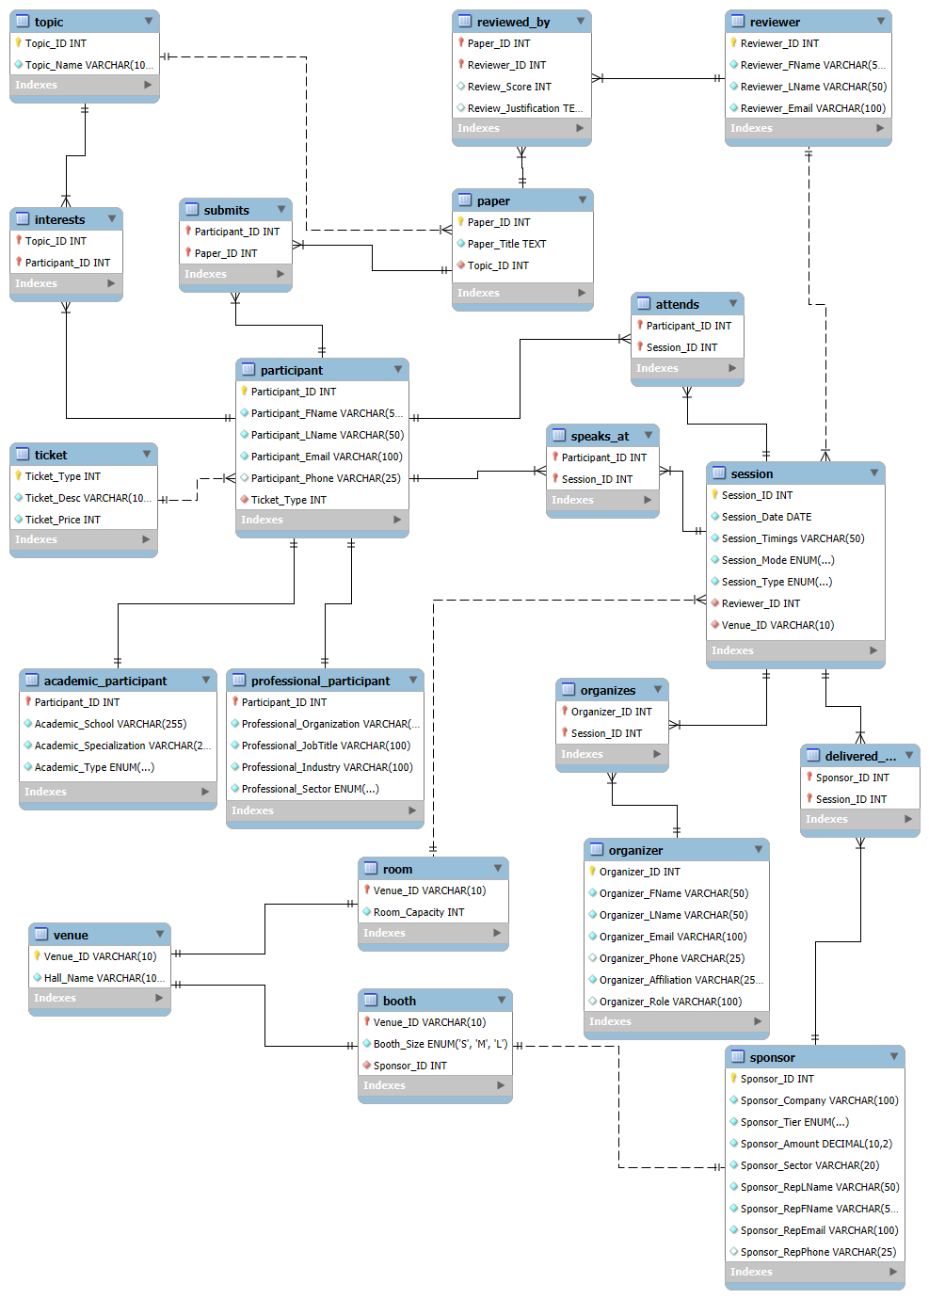

IV. Physical Design/Implementation
The database has been implemented in MySQL as per the data dictionary.
- Database name: conference_db
- It consists of 20 tables (including regular entities, subclass entities and bridge entities)
- The tables contain sample data part of which was generated from Mockaroo (http://mockaroo.com/) and Tonic Fabricate (https://fabricate.tonic.ai/)
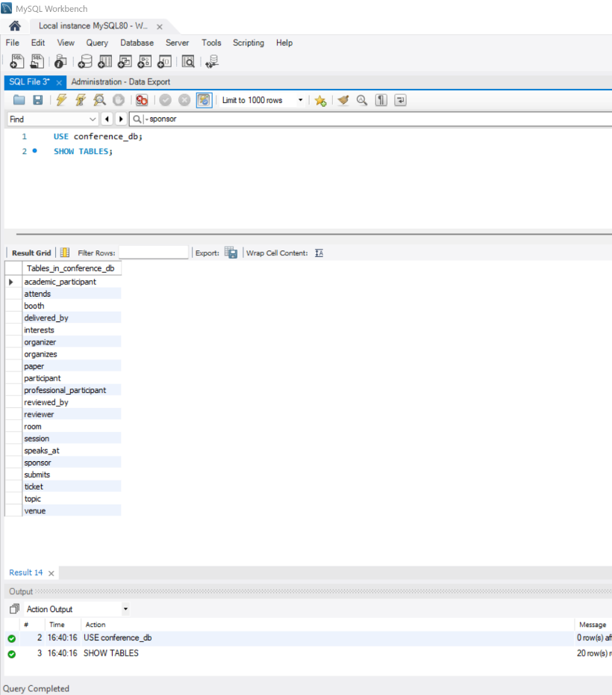

V. Querying/Reporting

Email addresses of all participants whose paper(s) have been accepted (avg review score >=7)
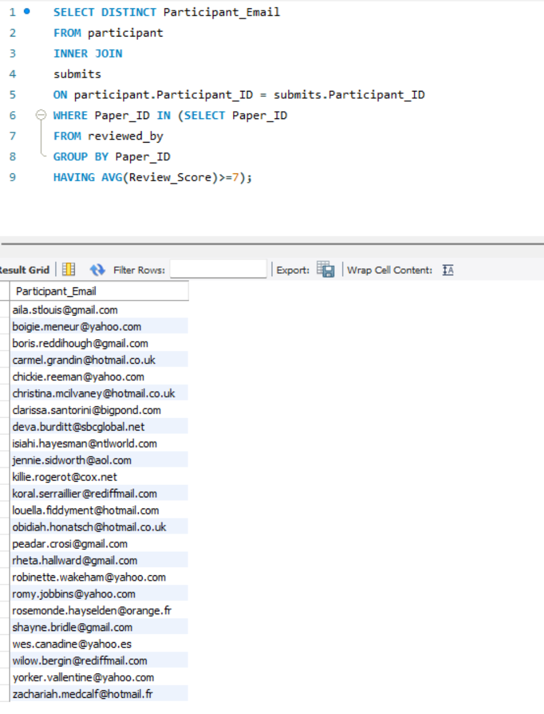

Sponsor summary across tiers (#sponsors, net earnings, average earning per sponsor)

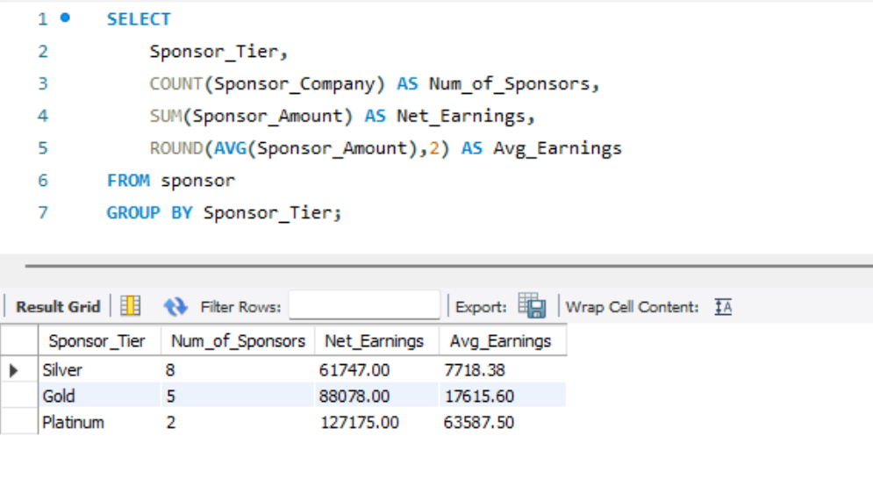

Specializations of academic participants

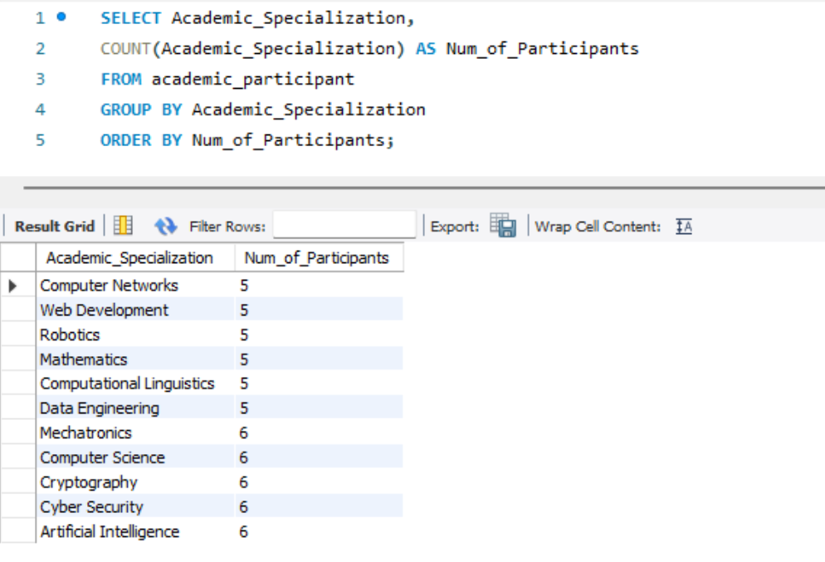

Organizations of professional participants

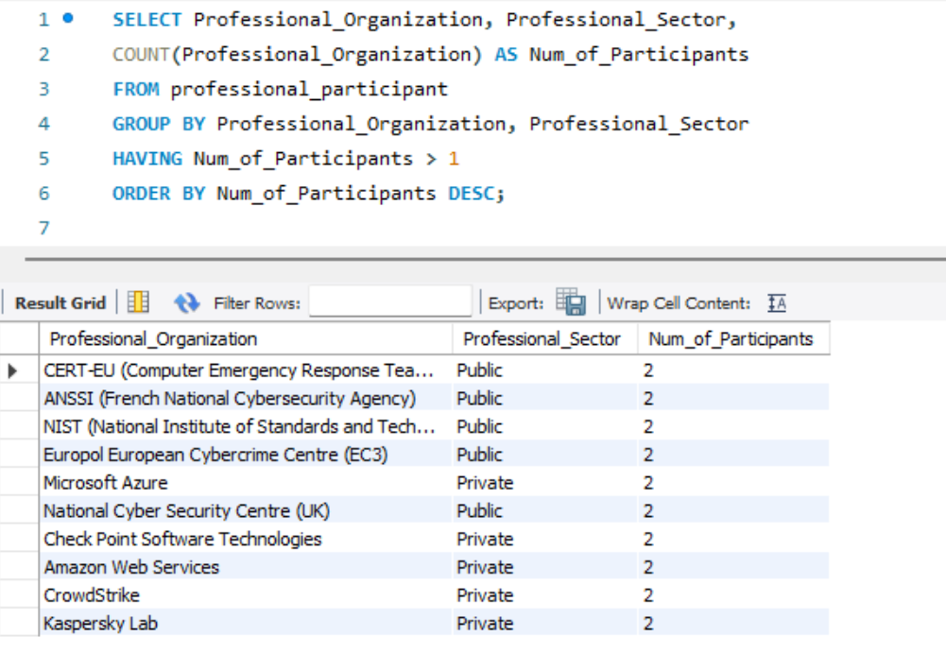

Number of sessions chaired by each reviewer

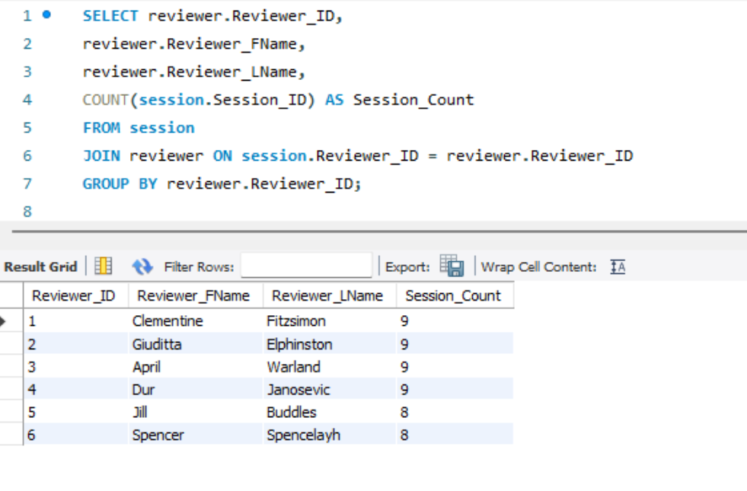

Count of papers and average review score by each reviewer

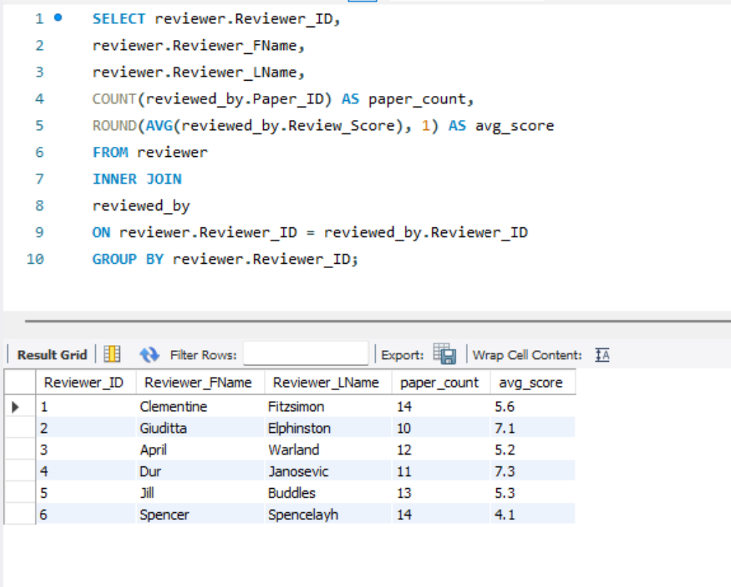

Ticket Summary based on ticket type (number of tickets sold and net earnings in EUR)

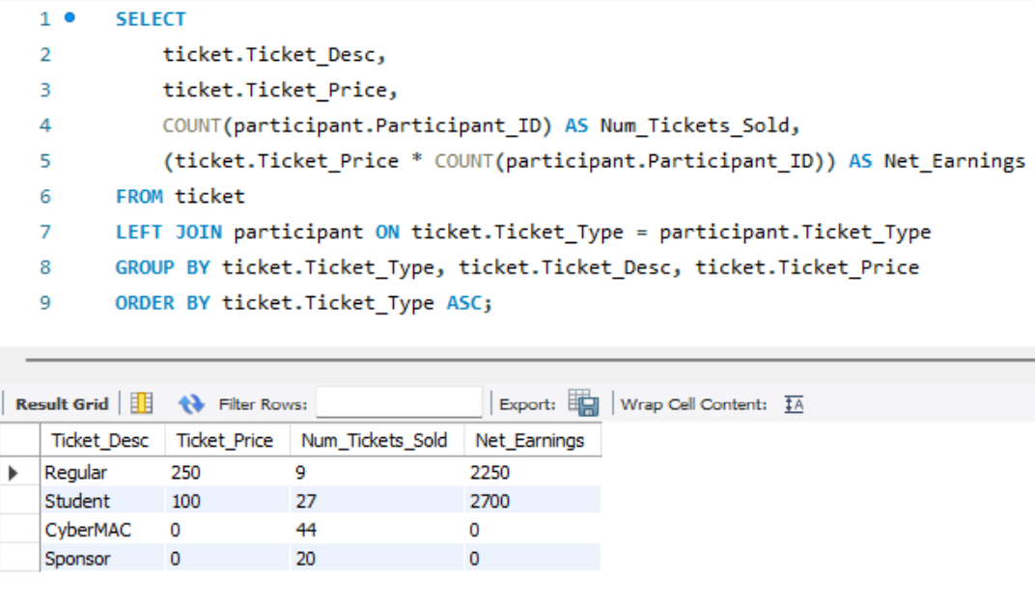

Details of papers under the topic “Digital Forensics”

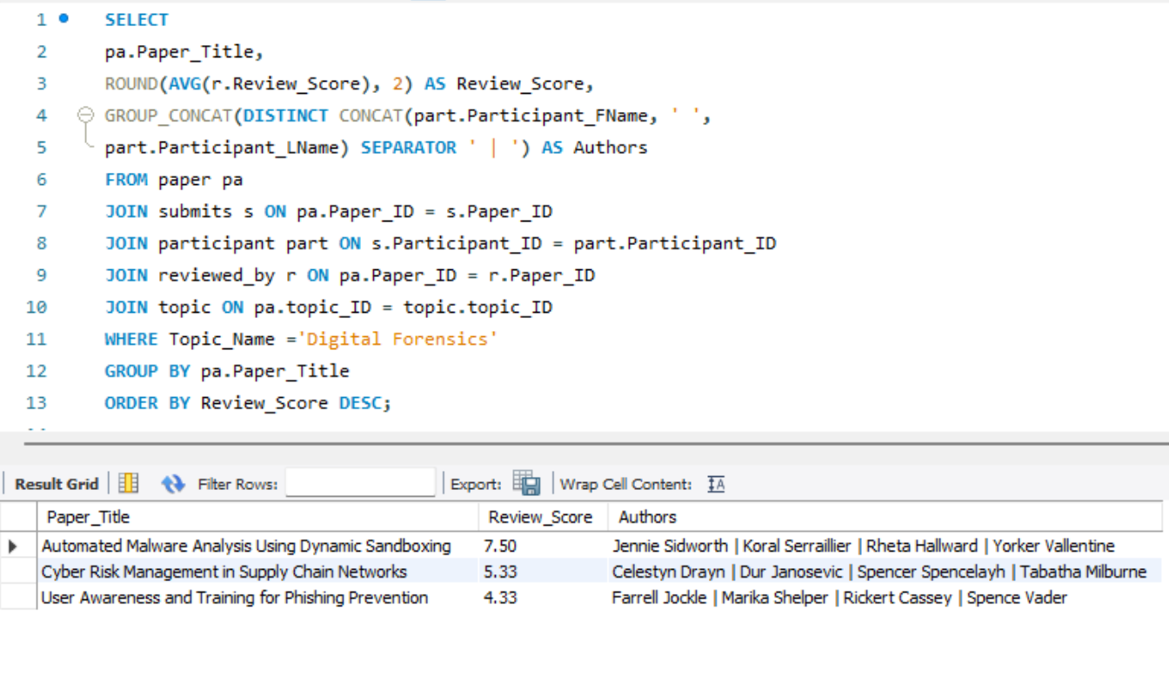

Booth Assignments of platinum sponsors

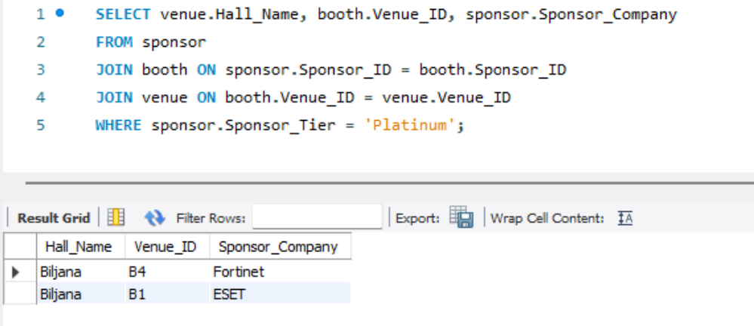

Session schedule with date, timings and assigned rooms (for offline sessions)

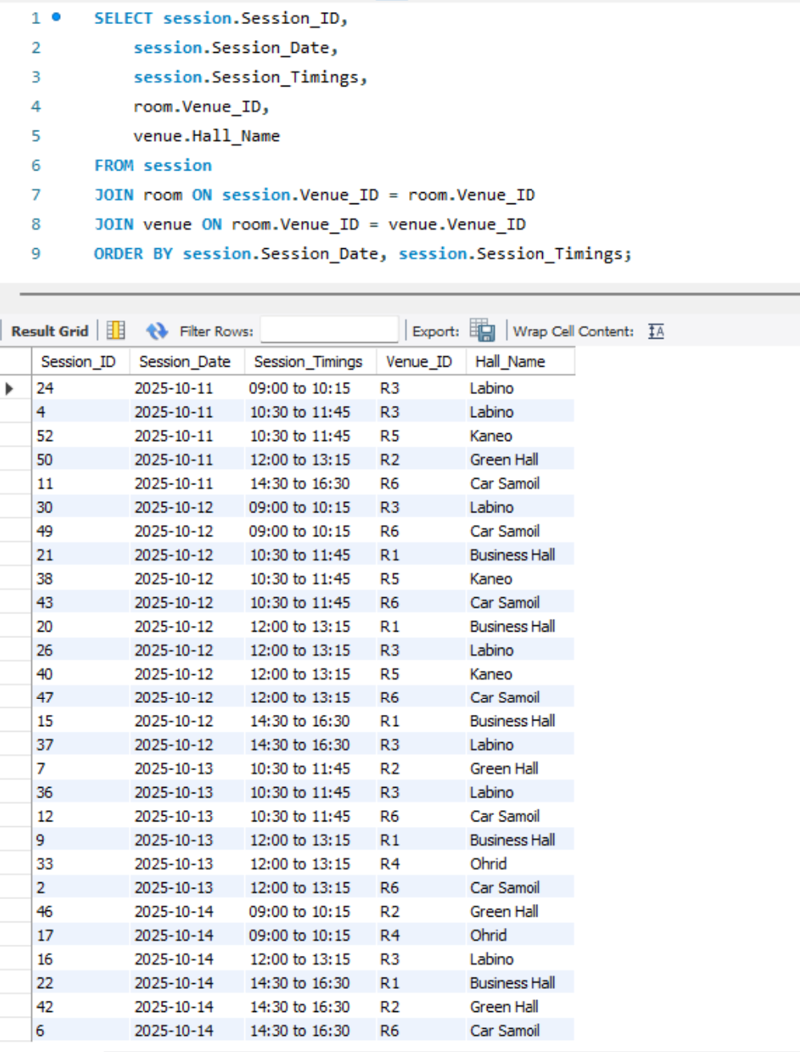

Topics Summary (number of papers received and interest by participants)

